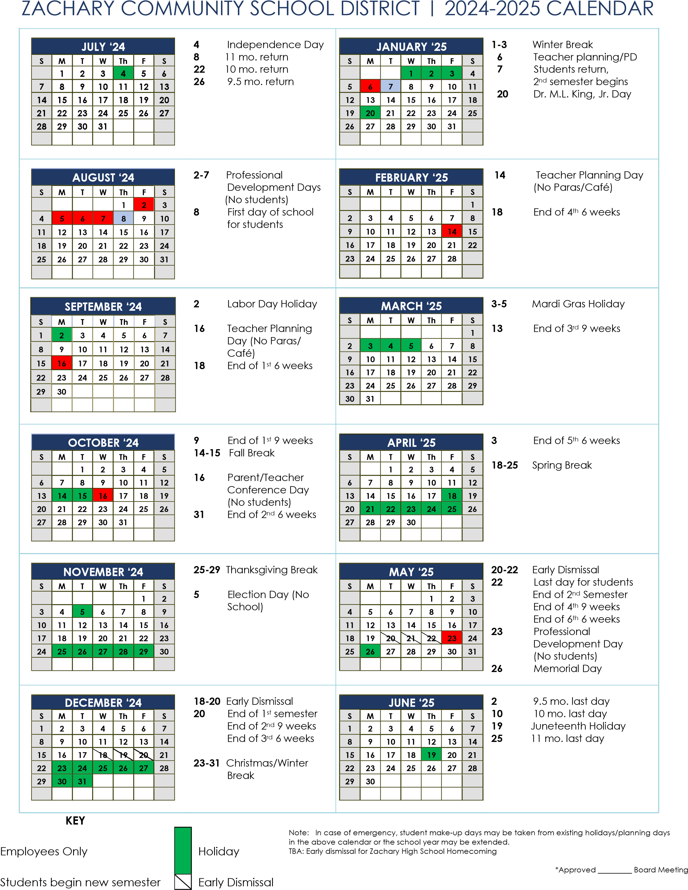

Holiday

**Key**

Employees only

2024-2025